Research Paper
Instrumented Digital Twin for Embedded Photovoltaic Controllers: Modeling ADC Quantization and Sensor Noise with Firmware-in-the-Loop Validation
Carlos René Suárez S.¹, Yimy Edison Garcia Rivera² and Alfonso Duran Caicedo ³
Academic Editor: Firstname Lastname
Received: date
Revised: date
Accepted: date
Published: date
Copyright: © 2026 by the authors. Submitted for possible open access publication under the terms and conditions of the Creative Commons Attribution (CC BY) license.
¹ Fundación Universitaria los Libertadores; crsuarezs@libertadores.edu.co
² Fundación Universitaria los Libertadores; yegarciav@libertadores.edu.co
3 Fundación Universitaria los Libertadores; alfonso.duran@libertadores.edu.co
* Correspondence: crsuarezs@libertadores.edu.co
Abstract
As the photovoltaic (PV) generation sector expands, the need for reliable maximum power point tracking (MPPT) in embedded controllers becomes increasingly pressing. However, MPPT studies rely on idealized simulation assumptions that neglect practical sensing limitations such as ADC quantization, finite measurement resolution, and sensor noise. This paper presents a novel instrumented digital twin of a PV array that integrates dynamic environmental excitation (irradiance and temperature variations) with a measurement-aware virtual instrumentation layer. Unlike conventional model-in-the-loop simulations, our proposed framework directly interfaces with embedded firmware executed on an ESP32 microcontroller, ensuring that the control algorithm operates solely on reconstructed, quantized measurements rather than ideal internal states. We validate time-domain behavior and assess the impact of instrumentation constraints on tracking stability and control dynamics using a classical Incremental Conductance (INC) MPPT implementation as a representative workload. Our approach enables repeatable and accessible firmware-level experimentation for realistic PV controller validation under non-ideal sensing conditions, making it an essential tool for developers seeking to improve the performance and reliability of their systems..
Keywords: photovoltaic digital twin; MPPT; embedded photovoltaic controllers; virtual instrumentation; photovoltaic modeling

1. Introduction
Photovoltaic (PV) energy has emerged as a renewable alternative for reducing dependence on fossil fuels and expanding low-emission electricity generation. However, PV modules' electrical operating points are strongly influenced by irradiance and temperature variations, necessitating maximum power point tracking (MPPT) techniques to maximize extracted power under changing environmental conditions [1,2]. MPPT strategies have been extensively reported in the literature, with classical methods like Perturb and Observe (P&O) and Incremental Conductance (INC) remaining widely adopted due to their low computational burden and suitability for embedded platforms [1,3].
Despite advances in MPPT algorithms, the practical behavior of any strategy still depends on the quality of measured voltage and current signals used to estimate PV operating conditions. In real implementations, controllers operate on digitized sensor signals affected by gain limits, finite input range, analog conditioning, quantization, sampling effects, and measurement noise [1,4].These non-idealities can alter derivative estimation, produce false convergence, amplify oscillations, and degrade stability or efficiency of MPPT operation.
The electrical behavior of photovoltaic generators is inherently complex and heavily influenced by environmental conditions, particularly irradiance and temperature. Accurate modeling of PV panels is essential for analyzing and validating control and energy conversion strategies. Widely used models, such as the single-diode model, strike a balance between physical accuracy and computational efficiency, enabling realistic simulations of current-voltage (I-V) and power-voltage (P-V) characteristics under varying operating conditions [1,5]. Irradiance variations primarily affect the photogenerated current, resulting in proportional changes to short-circuit current, while temperature variations influence open-circuit voltage, shifting the maximum power point (MPP) along the voltage axis [3,6]. These dependencies become crucial in practical installations, where environmental conditions vary continuously and PV arrays are often configured in series-parallel combinations to meet voltage and power requirements. As a result, a validation framework intended for embedded photovoltaic systems must be capable of representing both individual panel behavior and array-level configurations under dynamic environmental excitation.
Recent research has focused on improving MPPT performance through advanced control, adaptive logic, and global search mechanisms, particularly under mismatching or partial shading conditions [7,8]. However, these contributions do not fully address the instrumentation constraints that affect firmware-level behavior of embedded PV controllers during closed-loop operation. This paper proposes an instrumented digital twin for photovoltaic systems to systematically analyze how finite measurement resolution, sensing range selection, and sensor noise influence closed-loop embedded control behavior under dynamic irradiance and temperature conditions.
The related work mentions that many studies evaluate control performance using idealized simulation environments or simplified measurement assumptions that do not fully reflect the constraints of low-cost embedded hardware. This highlights the need for a more realistic and comprehensive validation framework that can accurately model the instrumentation constraints and sensor noise present in real-world PV systems. Overall, the related work provides context for the proposed instrumented digital twin approach, highlighting the limitations of existing methods and the importance of considering instrumentation constraints in MPPT research.

1.1 Digital Twins for Photovoltaic and Power Electronics Systems
Digital twins have become a popular approach to bridge the gap between theoretical models and real-world systems by providing a virtual counterpart that evolves consistently with the physical process [9,10]. Unlike traditional offline simulations, digital twins emphasize continuous interaction between the plant model, control logic, and execution environment, enabling repeatable and systematic experimentation under controlled conditions.
In the context of power electronics and photovoltaic systems, digital twins are often associated with model-in-the-loop (MIL), software-in-the-loop (SIL), and hardware-in-the-loop (HIL) validation methodologies [11–13] . These approaches have proven valuable for evaluating converter dynamics, control stability, and system-level interactions. However, existing platforms rely on idealized sensing assumptions or proprietary real-time hardware, limiting accessibility and obscuring the impact of measurement non-idealities on embedded control behavior.
Recent studies highlight that even high-fidelity HIL environments may fail to capture critical effects if the digital perception of the plant is simplified or abstract [14]. In embedded photovoltaic controllers, control decisions are made based on discretized, quantized, and noisy measurements rather than on ideal physical variables. A digital twin intended for realistic validation must therefore integrate not only the physical plant model but also the instrumentation and data acquisition chain data acquisition chain used to observe the plant. Experimental digital twins have been proposed to streamline simulation-based engineering by enabling systematic and repeatable experimentation [15].

1.2 Instrumentation and Measurement Constraints in Embedded Systems
In practical embedded systems, voltage and current measurements are affected by multiple sources of error introduced by the instrumentation chain. These errors include sensor scaling, limited dynamic range, analog offsets, thermal noise, and finite ADC resolution [16–18]. These effects are particularly relevant in low-cost microcontrollers commonly used in photovoltaic applications, where ADC resolution and input range are constrained by hardware limitations.
ADC quantization imposes a fundamental limit on measured signals, often modeled as additive noise with variance proportional to the least significant bit (LSB) size [19,20]. In digitally controlled power electronic systems, quantization effects have been shown to induce limit-cycle oscillations, bias errors, and degraded steady-state performance when the resolution of the measurement and actuation paths is insufficient [21,22]. The interaction between quantization, sampling rate, and digital control laws is therefore a structural issue rather than a marginal implementation detail. Measurement noise has been shown to reduce MPPT energy yield and induce false convergence, especially in derivative-based methods [23].
Despite this, different photovoltaic system studies implicitly assume ideal measurements or apply simplified noise models that do not reflect the constraints of embedded data acquisition. As a result, the influence of instrumentation design choices—such as sensing range selection or ADC resolution—on control behavior is often underestimated. Incorporating these effects explicitly within a validation framework is essential for assessing the robustness of embedded control strategies prior to hardware deployment.

1.3 MPPT as a Representative Embedded Control Application
Maximum Power Point Tracking (MPPT) is a common control task in photovoltaic energy systems and serves as an example of an embedded algorithm whose behavior is closely tied to measurement quality. Classic MPPT techniques, such as Perturb and Observe and Incremental Conductance, have been widely reported due to their simplicity and suitability for real-time implementation [3,23–25].
In this work, MPPT is not treated as an optimization problem, but rather as a practical embedded control application used to demonstrate the capabilities of the proposed digital twin. Among classic MPPT methods, Incremental Conductance is chosen as a case study due to its reliance on numerical differentiation of measured voltage and current signals, which makes it particularly sensitive to quantization, noise, and sensing range limitations [6,26]. This sensitivity allows instrumentation-induced effects to be clearly exposed within the digital twin environment.
By focusing on a single, well-established MPPT algorithm, the study avoids algorithmic comparison and instead emphasizes how measurement constraints influence control behavior. This approach aligns with the broader objective of the work: to evaluate the effectiveness of a measurement-aware digital twin as a tool for realistic validation of embedded photovoltaic control systems. Comprehensive surveys confirm that P&O and INC remain the most widely implemented classical MPPT strategies [27].”

1.4 Identified Gap and Positioning of This Work
Despite notable advancements in photovoltaic modeling, MPPT algorithm development, and digital twin creation, these areas are often tackled separately. Studies on MPPT rely on idealized simulations, while digital twin implementations frequently omit measurement chain details or require specialized hardware platforms. As a result, the combined effects of physical plant dynamics, instrumentation constraints, and embedded execution remain understudied in a unified and accessible framework. Comparative studies consistently report that algorithmic performance varies mostly under dynamic irradiance conditions, motivating controlled benchmarking [28].” This work bridges this gap by proposing a photovoltaic digital twin that seamlessly integrates physical modeling, virtual instrumentation, and firmware-level execution. By incorporating realistic sensing and quantization effects directly into the validation process, the proposed framework enables systematic evaluation of embedded control behavior under conditions that closely mirror real-world photovoltaic systems.

2. Materials and Methods

The materials and methods used in this study were defined to ensure that the proposed instrumented photovoltaic digital twin could be replicated, reparametrized, and extended by other researchers. We built the experimental framework around a photovoltaic array model, a virtual instrumentation layer, and an embedded firmware-in-the-loop interface based on an ESP32 microcontroller. In this research we parameterized the photovoltaic model using manufacturer datasheet information, including open-circuit voltage, short-circuit current, maximum power point values, temperature coefficients, irradiance dependence, and series–parallel array configuration. The virtual instrumentation layer reproduced practical measurement constraints such as voltage and current sensing ranges, gain and offset errors, ADC-compatible scaling, quantization, noise injection, ripple, and saturation. The embedded controller executed an Incremental Conductance MPPT algorithm using only reconstructed digitized measurements, without access to the internal states of the photovoltaic model. All experiments followed fixed environmental profiles, sampling conditions, firmware execution paths, and data logging procedures, allowing the same workflow to be repeated under ideal, realistic, and stress-level instrumentation scenarios. The following subsections describe the model equations, instrumentation assumptions, control implementation, experimental protocol, validation procedure, and performance metrics in sufficient detail to support reproducibility and future extensions of the published results.

2.1 Instrumented Photovoltaic Digital Twin Architecture
This section outlines the design of the proposed photovoltaic (PV) digital twin, highlighting its physical consistency, measurement-aware architecture, and embedded-oriented implementation. The digital twin is organized as a multi-layered system that distinctively separates the physical behavior of the PV array from the virtual instrumentation and the embedded control firmware. This layered structure closely replicates the signal flow encountered in practical PV energy conversion systems, providing a faithful representation of the complex interactions between the physical plant and the digital control loop.

2.1.1 Overall Architecture
The proposed photovoltaic (PV) digital twin consists of three intricately connected layers, designed to accurately replicate the complex interactions between the physical plant and the digital control loop.
Physical PV Array Model: This layer describes the electrical behavior of the photovoltaic panels as a function of load, irradiance, temperature, and array configuration, providing a detailed representation of the physical system.
Virtual Instrumentation Layer: This layer emulates voltage and current sensing, incorporating constraints such as scaling, saturation, and ADC quantization to accurately model real-world measurement limitations.
Embedded Interface Layer: Through this interface, an embedded microcontroller acquires measurements and executes MPPT algorithms without accessing internal model states, mimicking the constraints of real-world embedded PV controllers.
By separating these layers, the digital twin ensures that the control algorithm interacts exclusively with measured signals, faithfully reproducing the limitations and complexities of real-world embedded systems. Figure 1. shows the interaction between the photovoltaic plant signals, the measurement and signal-conditioning path, the controlled sensor distortion block, the ADC-related effects, and the embedded MPPT control loop executed on the ESP32 environment.
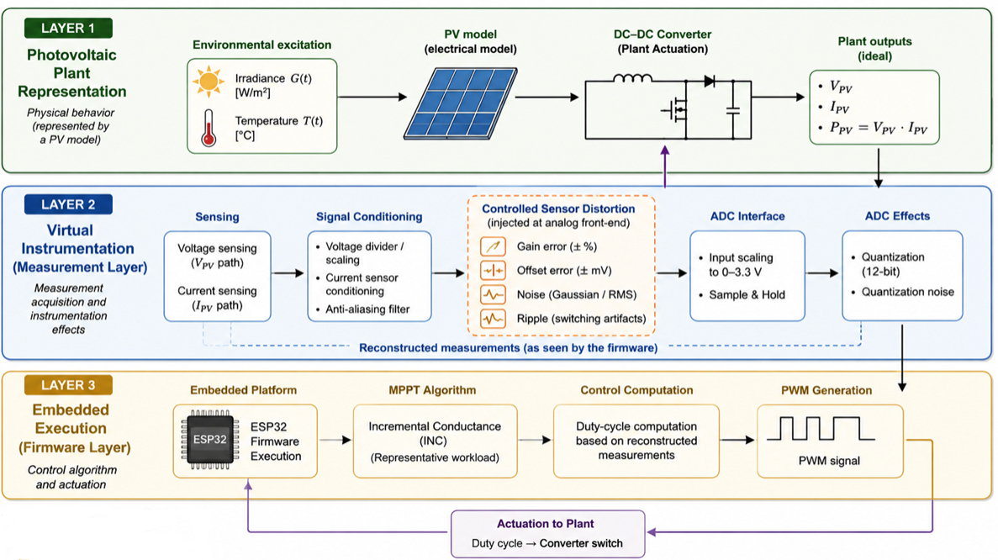

Figure 1. Detailed signal and control flow of the implemented instrumented digital twin.
The photovoltaic panel generates voltage and current signals that are processed through a measurement and signal conditioning stage, incorporating controlled gain, offset, noise, and ripple injection to simulate real-world measurement uncertainties. These degraded signals are then sampled by the ESP32 ADC and processed by the embedded MPPT algorithm, resulting in a duty cycle that controls a DC-DC converter and closes the loop between electrical dynamics and digital control. This structure enables realistic and repeatable evaluation of MPPT algorithms under controlled measurement uncertainties, departing from conventional approaches that rely on idealized plant outputs. Instead, our proposed architecture embeds voltage, current, irradiance, and temperature sensing effects directly into the panel-aside digital twin before ADC quantization, providing a more accurate representation of real-world conditions.

2.1.2 Physical Photovoltaic Model
The electrical behavior of a single photovoltaic panel is modeled using a physically consistent, first-order current-voltage (I-V) characteristic that accurately captures the dominant nonlinear behavior required for maximum power point tracking (MPPT) analysis. The open-circuit voltage and short-circuit current of a reference panel at standard test conditions (STC) are denoted by V_OC, ref and I_SC,ref, respectively, at an irradiance of 1000 W/m² and a temperature of 25°C.
- Irradiance Dependence
The short-circuit current scales linearly with irradiance. For a given irradiance G, the effective short-circuit current is expressed as:
$$I_{\text{SC}}(G)=I_{\text{SC,ref}}\frac{G}{G_{\text{ref}}}$$ | (1)
This relationship reflects the proportionality between incident solar radiation and photogenerated current in silicon PV cells.
- Temperature Dependence
Temperature effects are incorporated through empirical coefficients commonly reported in commercial PV module data sheets. The open-circuit voltage exhibits a dominant negative temperature coefficient:
$$V_{\text{OC}}(T)=V_{\text{OC,ref}}\left[1+α_{V}(T-T_{\text{ref}})\right]$$ | (2)
Where $α_{V}$ is the voltage temperature coefficient, typically around -0.3% degree Celsius. The short-circuit current is also affected by temperature, although to a much smaller extent:
$$I_{\text{SC}}(G,T)=I_{\text{SC}}(G)\left[1+α_{I}(T-T_{\text{ref}})\right]$$ | (3)
where $α_{I}$ is a small positive coefficient, typically about +0.04%per degree Celsius.
- Nonlinear I–V Characteristic
The instantaneous operating point of the PV panel is defined by a normalized load parameter $u∈$ [0,1], which represents the electrical loading imposed by the downstream power converter. The panel voltage is modeled as:
$$V_{\text{panel}}=V_{\text{OC}}(T)(1-u)$$ | (4)
It should be noted that the linear relationship between the panel voltage and the load parameter u constitutes a system-level abstraction. In an actual implementation with a buck or boost DC-DC converter, this relationship is nonlinear. Nevertheless, for instrumentation sensitivity studies focused on the MPPT algorithm rather than on the internal dynamics of the converter, this simplification is widely accepted and employed in numerous works on embedded MPPT validation.
The corresponding output current is given by:
$$I_{\text{panel}}=I_{\text{SC}}(G,T)\left[1 − {\left(\frac{V_{\text{panel}}}{V_{\text{OC}}(T)}\right)}^{K(T)}\right]$$ | (5)
where K(T) is a shape factor that determines the curvature of the I–V characteristic. To account for the degradation of maximum power with increasing temperature, the shape factor is made temperature-dependent:
$$(T)=K_{\text{ref}}\left[1-β_{K}(T-T_{\text{ref}})\right]$$ | (6)
with $β_{K}$ chosen to produce a moderate and realistic reduction in maximum power consistent with commercial PV modules.
- Series–Parallel Array Configuration
To represent arbitrary PV array configurations, the digital twin supports series–parallel scaling through two parameters: the number of panels in series Ns and the number of parallel strings Np. The array-level voltage and current are obtained as:
$$V_{\text{array}}=N_{s}⋅V_{\text{panel}},I_{\text{array}}=N_{p}⋅I_{\text{panel}}$$ | (7)
This formulation preserves the physical relationships of series and parallel connections while allowing the evaluation of MPPT algorithms under different array configurations.

2.1.3 Virtual Instrumentation and ADC Modeling
In practical embedded systems, voltage and current measurements are subject to sensor scaling and ADC limitations. To emulate this behavior, the digital twin includes a virtual instrumentation layer that maps physical quantities to ADC-compatible signals.
Let $V_{\text{sense,max}}$ and $I_{\text{sense,max}}$ represent the maximum measurable voltage and current, respectively, as determined by the virtual voltage divider and current transducer. The corresponding ADC voltages are calculated using the following equations:
$$V_{\text{ADC}}=\frac{V_{\text{array}}}{V_{\text{sense,max}}}V_{\text{ADC,max}},I_{\text{ADC}}=\frac{I_{\text{array}}}{I_{\text{sense,max}}}V_{\text{ADC,max}}$$ | (8)
where $V_{\text{ADC,max}}=3.3$ is the reference voltage of the ADC. Saturation is applied to ensure that the signals remain within the valid ADC range. The equations (8) define the analog scaling stage that maps the physical photovoltaic voltage and current into ADC-compatible voltage levels. However, in the embedded implementation, the ADC does not provide continuous voltage values; instead, it converts the scaled analog signal into a finite-resolution digital representation. Therefore, after scaling and saturation, an explicit quantization stage is included.
$∆=\frac{V_{ADC,max}}{2^{N}}$, $V_{ADC,quant}=∆.round(\frac{V_{ADC}}{∆})$, $eq=V_{ADC,quant}-V_{ADC, }$ | (9)
$${eq\sim u(-\frac{∆}{2},\frac{∆}{2})}_{ , }{ σ^{2}=\frac{∆^{2}}{2}, ∆=\frac{V_{ADC,max}}{4096}}_{ }$$
The equations (9) describe the analog scaling stage, where the physical photovoltaic voltage and current are mapped into ADC-compatible voltage levels. However, the embedded ADC does not provide continuous voltage values; instead, it converts the scaled analog input into a finite-resolution digital measurement. Therefore, after scaling and saturation, the ADC quantization stage is explicitly modeled.
Environmental variables are exposed through dedicated virtual sensors:
$$G_{\text{ADC}}=\frac{G}{G_{\text{max}}}V_{\text{ADC,max}},T_{\text{ADC}}=\frac{T}{T_{\text{max}}}V_{\text{ADC,max}}$$ | (10)
This design allows the embedded controller to access irradiance and temperature measurements in the same manner as additional analog sensors.

2.1.4 Embedded Interface and Execution Model
The digital twin communicates with an ESP32 microcontroller through analog input channels, allowing the embedded firmware to reconstruct physical quantities using known sensing ranges and ADC resolution. However, the firmware has no access to the internal states or equations of the PV model, mirroring the constraints of a real embedded photovoltaic controller. By combining a physically consistent PV model with a measurement-aware instrumentation layer and firmware-level execution, the proposed digital twin provides a realistic and reproducible platform for evaluating MPPT algorithms under practical embedded constraints.
Common Baseline Plant Model Throughout this work, the proposed digital twin and its instrumentation configuration remain unchanged, serving as a common baseline plant model. The MPPT algorithm evaluated in subsequent sections operate on the same digital twin without modifying their physical or measurement characteristics, ensuring a fair and consistent evaluation of their performance under realistic embedded system constraints.

2.2 Embedded Control Case Study within the Digital Twin
This section highlights an embedded control case study used to evaluate and validate the proposed instrumented photovoltaic digital twin. Rather than introducing or comparing MPPT algorithms, this section aims to demonstrate how a typical embedded control task interacts with the digital twin under realistic measurement constraints. The MPPT case study serves solely as a functional workload that enables the analysis of instrumentation-induced effects within the proposed framework.

2.2.1 Role of MPPT within the Digital Twin Framework
In photovoltaic energy systems, MPPT is a standard control task implemented in embedded controllers to ensure operation close to the maximum power point under varying environmental conditions. In this digital twin framework, Maximum Power Point Tracking (MPPT) plays a role as a standard control task that ensures photovoltaic energy systems operate near maximum power under varying conditions. MPPT's reliance on measured voltage and current signals makes it an ideal workload for digital twin validation, as its behavior is heavily influenced by sensing resolution, quantization, and noise.
In this work, MPPT serves as a representative embedded control application to demonstrate the capabilities of the proposed instrumented digital twin. The focus lies not in developing or optimizing MPPT algorithms, but rather in showcasing how realistic measurement modeling affects control decisions when controllers operate solely on digitized signals provided by the virtual instrumentation layer.
To avoid algorithm-centric interpretation, a single embedded-oriented MPPT controller configuration is selected as the case study, enabling controlled analysis of instrumentation effects without pursuing algorithmic optimization for this case study, allowing for a controlled analysis of instrumentation effects without introducing additional complexity associated with algorithmic comparison.

2.2.2 Improved Incremental Conductance MPPT (Case Study)
To design effective photovoltaic systems, it is crucial to develop maximum power point tracking (MPPT) control algorithms that minimize energy losses and maintain rapid transient response under dynamic irradiance conditions [3,23]. While classical MPPT strategies can deliver competitive tracking performance under stable operating conditions, they often exhibit significant deviations under rapid environmental disturbances, measurement noise, and sensing constraints typically encountered in embedded implementations [3,25,28]. This highlights the need for validation frameworks capable of rigorously testing MPPT firmware under realistic data acquisition limitations, thereby ensuring reliable performance under real-world operating scenarios.
In this work, we choose the Incremental Conductance (INC) method as our representative embedded MPPT workload due to its widespread adoption and suitability for embedded systems, as well as its sensitivity to measurement imperfections introduced by finite-resolution sensing [6]. To enhance practical stability while maintaining low computational complexity, we implement an enhanced INC formulation that incorporates derivative filtering and an adaptive step-size update, which has been reported as an effective improvement of classical INC for embedded PV applications [29]. This configuration is deliberately selected to reduce noise-driven oscillations and provide a deterministic firmware workload suitable for repeatable instrumentation sensitivity experiments within the proposed digital twin framework.
Its i's key to acknowledge that challenging PV operating scenarios like partial shading can create multiple local maxima in the P-V curve, where classical techniques may get stuck, and optimization-based MPPT approaches such as particle swarm optimization (PSO) have been explored to enhance robustness in these cases [30,31]. Nevertheless, since our primary goal is to assess the impact of instrumentation constraints (ADC quantization, sensing range selection, and measurement noise) on embedded control behavior, our experimental study is deliberately limited to a single, embedded-oriented INC workload under controlled irradiance and temperature excitation, avoiding algorithmic comparison and advanced optimization strategies. At the optimal operating point, the incremental conductance and instantaneous conductance have equal magnitudes but opposite sign. At the maximum power point (MPP), the incremental conductance dI/dV is negative and the instantaneous conductance I/V is positive, satisfying the relationship:
This opposite-sign equality is the foundation of the decision criterion of the Incremental Conductance algorithm.
$$\frac{dI}{dV}=-\frac{I}{V}$$ | (11)

To reduce sensitivity to measurement noise, the numerical derivatives are filtered using a first-order IIR filter:
$$ΔV_{f}\left(k\right)=αΔV\left(k\right)+\left(1-α\right)ΔV_{f}\left(k-1\right)$$  $$ΔI_{f}\left(k\right)=αΔI\left(k\right)+\left(1-α\right)ΔI_{f}\left(k-1\right)$$ | (12)
with α ∈ (0,1) being the filter constant (in this work, α = 0.3).

In practical embedded implementations, this condition is evaluated using finite differences between digitized voltage and current samples. Therefore, ADC quantization of ΔV and ΔI, noise amplification through numerical division, and the tolerance parameter ε—linked to effective resolution determined by sensing range and ADC characteristics—make INC particularly suitable for revealing instrumentation-induced degradation when executed within the proposed measurement-aware digital twin.
Algorithm: Improved Incremental Conductance MPPT (Filtered + Adaptive Step)
Inputs: Measured voltage V(k), measured current I(k), previous voltage V(k-1), previous current I(k-1)
Parameters: Control step Δu, conductance tolerance ε
Output: Updated control variable u(k)
Initialize:
Measure V(0), I(0)
Set initial control u(0)
For each sampling instant k:
Measure V(k), I(k)
ΔV=V(k)-V(k-1)
ΔI=I(k)-I(k-1)
ΔVf = α·ΔV + (1−α)·ΔVf_prev
ΔIf = α·ΔI + (1−α)·ΔIf_prev
Compute error e = (ΔIf/ΔVf) + I/V
Δu = Δu0·clip(|e|·K, umin, umax) with dead-zone if |e|<εe
If ∣ΔV∣<ε:
If ∣ΔI∣<ε:
u(k)=u(k-1)// Operating at MPP
Else if ΔI>0:
u(k)=u(k-1)-Δu
Else:
u(k)=u(k-1)+Δu
Else:
If ΔI/ΔV>-(I(k))/(V(k)):
u(k)=u(k-1)-Δu
Else if ΔI/ΔV<-(I(k))/(V(k)):
u(k)=u(k-1)+Δu
Else:
u(k)=u(k-1)
Apply u(k)
Store V(k), I(k)

Although Incremental Conductance can theoretically eliminate steady-state oscillations under ideal conditions, its embedded implementation is inherently sensitive to measurement imperfections. The quantization of voltage and current differences by the ADC, amplification of noise through numerical division, and the ε parameter's direct relation to the effective resolution determined by sensing range and ADC characteristics make INC particularly well-suited for revealing instrumentation-induced degradation when executed within the proposed digital twin framework.

2.2.3 Implementation Consistency and Scope of the Case Study
To isolate the effects of instrumentation constraints, we implemented the Incremental Conductance algorithm under consistent conditions throughout the study. The photovoltaic plant model, environmental profiles, firmware structure, sampling rate, and actuation limits remained unchanged across all experiments. In this research we used the same firmware binary across all experiments; only the instrumentation parameters were modified. This ensured that the observed differences in tracking behavior, control activity, steady-state oscillation, and convergence response could be attributed to sensing-stage effects rather than to changes in the embedded control implementation.
The MPPT implementation presented here is not intended to be a novel contribution or an optimized solution. Instead, it serves as a deterministic and reproducible control workload that interacts with the digital twin through digitized measurements. Advanced MPPT techniques were intentionally excluded to focus on embedded-friendly controllers commonly used in commercial photovoltaic systems.
By limiting the case study to a single classical MPPT method, the analysis highlights the impact of sensing range selection, ADC resolution, and measurement noise on control behavior, rather than differences between control strategies. This approach ensures consistency with the overall objective of the work: validating the proposed instrumented digital twin as a realistic and practical framework for evaluating embedded photovoltaic systems.

2.3. Experimental Methodology
In this section, we outline the experimental methodology employed to investigate the influence of instrumentation design decisions on the behavior of embedded control systems within our proposed photovoltaic digital twin. We utilize a single classical controller workload (Incremental Conductance) and execute it under controlled environmental conditions while systematically varying sensing ranges, effective ADC resolution, and measurement noise levels. This protocol allows for repeatable and quantitative observations of the effects induced by instrumentation choices on realistic embedded measurement constraints, without relying on idealized internal model states.

2.3.1 Test Scenarios
We intentionally design evaluation scenarios to isolate and quantify the impact of environmental dynamics and instrumentation constraints on embedded control behavior within our proposed digital twin. Each scenario is executed independently and repeated multiple times to ensure statistical consistency, allowing us to conduct a controlled assessment of the effects induced by measurement limitations.
- Environmental Dynamics
We execute the embedded control workload (Incremental Conductance) under various environmental excitation profiles, simulating real-world operating conditions commonly experienced in photovoltaic systems:
Steady-State Operation: Constant irradiance and temperature are applied to assess steady-state behavior, highlighting oscillations, limit cycles, and sensitivity to ADC quantization.
Irradiance Step Change: A sudden irradiance variation is introduced to emulate fast cloud transients, enabling observation of convergence behavior, transient tracking disturbances, and robustness to abrupt power changes.
Irradiance Ramp: A smooth irradiance ramp is applied to represent gradual atmospheric variations, allowing evaluation of how the embedded controller responds to continuously changing operating points and how measurement noise influences decision stability.
Temperature Variation: Cell temperature varies while maintaining constant irradiance to evaluate the impact of temperature-driven power degradation and voltage shift on the operating point evolution observed through digitized measurements.
These scenarios ensure that the digital twin exposes both steady-state and transient operating conditions while maintaining a fully controlled and repeatable experimental setting.
- Instrumentation Constraints
To investigate how instrumentation design decisions affect embedded control behavior, we comprehensively evaluate various sensing configurations in a systematic manner:
Voltage Sensing Range Variation: The maximum measurable voltage is varied while keeping the physical panel voltage unchanged, emulating different divider ratios and ADC utilization levels.
Current Sensing Range Variation: The maximum measurable current is varied to assess the impact of course versus fine current resolution on finite-difference computations and decision sensitivity.
Effective ADC Resolution Degradation: Sensing ranges are adjusted while maintaining a fixed ADC nominal resolution to intentionally reduce the effective number of usable bits, enabling direct observation of quantization-driven effects.
We consider realistic embedded design compromises, where sensing range selections are made to prioritize fault tolerance and over-range protection during normal operation, albeit at the cost of reduced resolution.

2.3.2 Experimental Protocol
All experiments followed a fixed and time-consistent execution protocol to ensure repeatability and isolate the effects of the virtual instrumentation layer on embedded MPPT behavior. We executed each run using the same firmware structure, sampling period, ADC resolution, ADC averaging, sensing interface, data logging format, and Incremental Conductance implementation. The controller initialized from a predefined operating condition and then exposed to controlled environmental or instrumentation perturbations. The logged variables included time, reconstructed PV voltage, reconstructed PV current, extracted power, irradiance, cell temperature, equivalent load, ADC raw counts, ADC-equivalent voltages, finite differences of voltage and current, and the MPPT control variable.
A relevant feature of the proposed digital twin is that it can be used not only as a fixed simulation of a single photovoltaic module, but also as an experimental platform for emulating different commercial panels through parameter adjustment. In this sense, the digital twin is transferable across PV module technologies at the methodological level: the same physical-model structure, virtual instrumentation layer, and embedded firmware interface can be preserved, while the panel-specific electrical and thermal parameters are modified according to datasheet information. Therefore, a user can reproduce the experimental workflow with another PV module by updating parameters such as open-circuit voltage, short-circuit current, maximum power point values, temperature coefficients, irradiance response, and series-parallel configuration, without modifying the embedded MPPT firmware or the measurement-aware validation structure.
To verify this capability, we incorporated a cross-panel comparison using three commercial references: Mitsubishi PV-MJT250GB, Canadian Solar BiHiKu7 CS7L-580MB-AG, and Helios Plus 425–450M. These panels were selected because their available technical information provides normalized curves, $I-V$ characteristics, temperature coefficients, or irradiance-dependent behavior suitable for comparison with the digital twin output. The Mitsubishi module is hold as the baseline reference because its datasheet includes normalized curves for ($I_{sc}$), ($V_{oc}$), and ($P_{max}$) as functions of irradiance and temperature. The Canadian Solar CS7L-580MB-AG module as a high-power commercial module with PERC-based characteristics, allowing the verification of whether the same digital twin structure can be reparameterized for a modern large-area module. The Helios Plus 425–450M module as an additional commercial reference for comparison of irradiance-dependent I–V behavior.
Because the selected panels have different rated powers, voltage levels, current ratings, and technologies, we performed the comparison using normalized values rather than absolute power values. For irradiance variation, we normalized the maximum power with respect to the value at (1000,W/m^2). For temperature variation, we normalized the maximum power with respect to the value at (25^\circ C). This procedure allows the comparison to focus on the physical trend of each module instead of its nominal power rating, as shown in Figure 2.
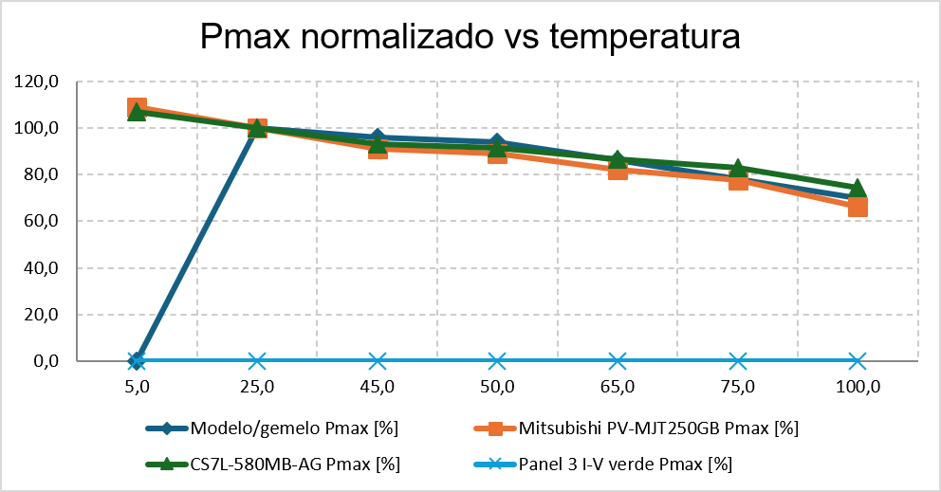
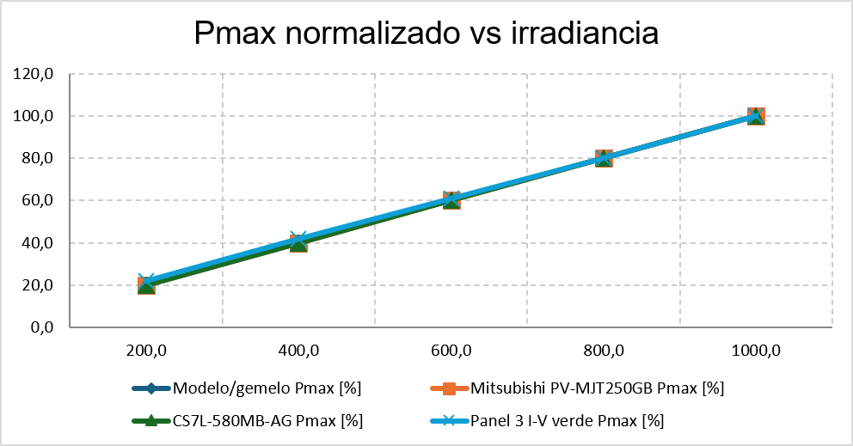

- (b)
Figure 2. (a) Irradiance dependence comparison (datasheet vs digital twin); (b) Temperature dependence comparison (datasheet vs digital twin).
Figure 2(a) shows the normalized $P_{max}$ response as a function of irradiance for the digital twin and the selected commercial panels. The curves show a proportional increase in $P_{max}$ as irradiance increases from 200 to (1000,W/$m^{2}$). This confirms that the digital twin reproduces the dominant photovoltaic behavior required for MPPT validation under irradiance changes: the available power scales strongly with irradiance, while the voltage-related response remains comparatively less sensitive. The small differences among curves are expected because each panel technology and datasheet representation has different electrical parameters and curve shapes.
Figure 2(b) shows the normalized $P_{max}$ response as a function of cell temperature. The Mitsubishi PV-MJT250GB and Canadian Solar CS7L-580MB-AG references show the expected reduction in maximum power as cell temperature increases. The slope of this reduction is not identical because each module has its own temperature coefficient and technology-dependent behavior. For the Helios Plus 425–450M module, this study did not extrapolate the temperature-dependent $P_{max}$ curve when the available information did not directly support it. Therefore, the absence of a comparable thermal curve for this module should not be interpreted as a physical lack of thermal degradation, but as a methodological decision to avoid unsupported extrapolation.

Table 1. Cross-panel validation summary using normalized datasheet-based trends.
Reference module | Reference information used | Irradiance comparison | Temperature comparison | Main interpretation
Mitsubishi PV-MJT250GB | Normalized datasheet curves for $I_{sc}$, $V_{oc}$, and $P_{max}$ | $P_{max}$ increases proportionally with irradiance | $P_{max}$decreases with increasing cell temperature | Used baseline reference because both irradiance and temperature dependencies are explicitly available.
Canadian Solar BiHiKu7 CS7L-580MB-AG | I–V curves and thermal coefficient information | $P_{max}$follows the expected irradiance-dependent trend | Thermal behavior estimated from available temperature coefficient information | Confirms that the same digital twin structure can be reparameterized for a high-power PERC-based module.
Helios Plus 425–450M | $I-V$ curves under different irradiance levels | $P_{max}$follows the expected irradiance-dependent trend | Not extrapolated when temperature-dependent $P_{max}$information is not directly available | Used to verify irradiance-dependent transferability without forcing unsupported thermal behavior.

The cross-panel comparison confirms that the proposed digital twin is not limited to a single PV module. Instead, it can be used as a reusable experimental environment in which different panels can be emulated by adjusting their datasheet-based parameters. However, the comparison also shows that numerical results are not directly transferable from one panel to another. Each module requires its own parameterization and validation before drawing quantitative conclusions. Consequently, the framework should be understood as a transferable measurement-aware validation architecture, rather than as a universal fixed-parameter photovoltaic model.
This protocol also supports reproducibility. Any researcher or developer can use the proposed digital twin to experiment with another commercial PV module, provided that the corresponding datasheet or experimental I–V/P–V information is available. Once the panel parameters are updated, the same embedded firmware, ADC modeling, sensing-range configuration, and instrumentation-sensitivity tests can be reused. This enables controlled evaluation of MPPT behavior under different PV technologies while preserving the same firmware-in-the-loop validation conditions.

2.3.3 PV Model Validation against Manufacturer Datasheet
We initiated the experimental workflow by validating the photovoltaic model used as the plant representation within the proposed digital twin. It is important to clarify that we used Wokwi as the embedded simulation environment for ESP32 firmware execution, virtual sensing, and data acquisition, rather than as a native photovoltaic simulator. In this research we represented the PV by an externally defined mathematical model coupled to the Wokwi-based embedded environment through reconstructed voltage, current, irradiance, and temperature signals.
In this project we integrated the modeled PV plant with an ESP32 microcontroller and a virtual sensing layer, allowing synchronized acquisition of the main electrical and environmental variables, including panel voltage, panel current, extracted power, irradiance, and cell temperature. This process resulted in the consolidation of an eight-column dataset that captures the dynamic behavior of the modeled PV system under different operating conditions, providing a consistent baseline for subsequent measurement-aware embedded control analysis.
We developed and executed a dedicated Python processing pipeline to perform signal conditioning and technical characterization. The algorithm implemented a transient-suppression strategy by trimming initial and final samples from each sweep, thereby eliminating plotting artifacts caused by incomplete or non-representative measurements at the boundaries of the acquisition window. Furthermore, we incorporated a moving-average smoothing stage to mitigate quantization fluctuations and residual measurement noise, ensuring that the extracted trends preserve the expected physical dependencies of photovoltaic behavior.
We also used the same processing script to automatically generate normalized characteristic curves consistent with standard PV datasheet representation. Specifically, temperature- and irradiance-dependent curves were scaled to 100% relative to their peak values, allowing direct comparison of power degradation under temperature increase and voltage sensitivity under irradiance variation. The results confirm that, after filtering and normalization, the simulated PV model reproduces the expected first-order behavior of the Mitsubishi PV-MJT250GB panel: maximum power decreases monotonically with increasing temperature, maximum power scales linearly with irradiance, and open-circuit voltage remains weakly dependent on irradiance.
Therefore, the proposed PV model and measurement-aware processing pipeline provide a reliable foundation for firmware-level analysis under controlled environmental excitation. In the remainder of this work, the Incremental Conductance algorithm is used as a representative embedded MPPT workload to systematically analyze instrumentation-induced effects associated with reconstructed measurements, ADC quantization, and measurement noise.

2.3.4 Performance Metrics
The performance of the Incremental Conductance algorithm is evaluated using quantitative metrics commonly adopted in MPPT analysis, complemented by indicators sensitive to instrumentation-induced degradation.
- Tracking Efficiency
Tracking efficiency is defined as:
$$η_{\text{MPPT}}=\frac{\sum_{k=1}^{N}{P_{\text{extracted}}}(k)}{\sum_{k=1}^{N}{P_{\text{MPP,true}}}(k)}$$ | (13)
where $P_{MPP,true}$ is obtained directly from the digital twin model under identical environmental conditions.
- Convergence Time
The convergence time $t_{conv}$ is defined as the time required for the operating point to enter and remain within a predefined tolerance band around the MPP following an environmental disturbance.
- Steady-State Oscillation
Steady-state oscillations are quantified using the standard deviation of the extracted power:
$$σ_{P}=\sqrt{\frac{1}{N}\sum_{k=1}^{N}{(P(k)-}\overset{ˉ}{P})^{2}}$$ | (14)
These metric captures limit cycles and residual perturbations around the MPP.
- MPP Deviation Index (MDI)
To quantify average deviation from the theoretical MPP, the MPP Deviation Index is defined as:
$$\text{MDI}=\frac{1}{N}\sum_{k=1}^{N}{∣\frac{P(k)-P_{\text{MPP,true}}(k)}{P_{\text{MPP,true}}(k)}∣}$$ | (15)
This index is particularly sensitive to quantization and noise-induced errors.
- Robustness to Measurement Noise
Robustness is assessed qualitatively and quantitatively by identifying:
- false convergence events,
- oscillatory divergence,
- tracking stalls near the MPP.

2.3.5 Experimental Procedure
Each experimental run follows the same procedure to guarantee repeatability:
- Initialization
The MPPT algorithm is initialized at an operating point deliberately chosen far from the MPP.
- Scenario Execution
One test scenario (environmental or instrumentation-based) is applied while all other parameters remain constant.
- Data Acquisition
The following variables are logged at each sampling instant:
- Photovoltaic voltage V
- Photovoltaic current I
- Extracted power P
- Control variable (duty cycle or virtual load)
- Irradiance G
- Cell temperature T
- Instrumentation Sweep
The full procedure is repeated for different sensing ranges to isolate instrumentation effects.
Table 2 defines the common temporal structure applied to all instrumentation scenarios. This structure ensure that the observed differences among scenarios can be attributed to the imposed measurement distortions rather than to changes in irradiance, temperature, firmware execution, or control timing. All experiments were conducted using the same embedded firmware execution path, the same sampling structure, and the same environmental profiles.
The temporal sequence combines steady-state operation, MPPT activation, irradiance step variation, irradiance ramp variation, and temperature variation. Phase A0 provides a fixed-load baseline before enabling closed-loop control. Phase A1 evaluates MPPT behavior under constant irradiance and temperature. Phases A2 and A3 introduce irradiance disturbances with different dynamic characteristics, while Phase A4 evaluates the response under thermal variation. This staged structure provides a controlled basis for interpreting the results presented later, particularly the tracking efficiency, control activity, convergence behavior, and steady-state power oscillation obtained under ideal, realistic, and stressed instrumentation conditions.

Table 2. Common Temporal Structure (Applied to All Scenarios).
Phase | Time Interval (s) | Irradiance Profile G(t) [W/m²] | Temperature Profile T(t) [°C] | Control Mode
A0 | 0–60 | 800 (constant) | 25 (constant) | Fixed load = 70% (no MPPT)
A1 | 60–180 | 800 (constant) | 25 (constant) | MPPT enabled
A2 | 180–300 | 400 → 800 (step) | 25 (constant) | MPPT enabled
A3 | 300–520 | 300 → 800 (ramp + plateau) | 25 (constant) | MPPT enabled
A4 | 520–860 | 800 (constant) | 60 → 25 | MPPT enabled

Three scenarios are designed to provide strict comparability between experiments by sharing identical temporal excitation profiles in terms of irradiance and temperature. The only variation lies in the instrumentation layer, where progressively higher levels of measurement distortion are introduced. Table 3 presents the configuration of the three scenarios.
Table 3. Instrumentation Conditions per Scenario.
Scenario | Description | Vgain (%) | Voffset (mV / %FS) | Vnoise (mV RMS / %FS) | Vripple (mV pk / %FS) | Igain (%) | Ioffset (mV / %FS) | Inoise (mV RMS / %FS) | Iripple (mV pk / %FS)
Scenario A Ideal | Ideal instrumentation | 0.0 | 0.0 / 0.000 | 0.0 / 0.000 | 0.0 / 0.000 | 0.0 | 0.0 / 0.000 | 0.0 / 0.000 | 0.0 / 0.000
Scenario B Realistic | Moderate sensing imperfections | +0.8 | 2.3 / 0.070 | 1.5 / 0.045 | 2.0 / 0.061 | −0.8 | 1.1 / 0.033 | 0.8 / 0.024 | 1.2 / 0.036
Scenario C Stress | Severe sensing degradation | +3.0 | 7.0 / 0.212 | 4.5 / 0.136 | 6.0 / 0.182 | −2.5 | 3.5 / 0.106 | 2.5 / 0.076 | 3.0 / 0.091

Scenario A represents ideal sensing conditions, while Scenarios B and C simulate realistic sensor imperfections typically found in embedded systems and extreme measurement degradation, respectively. This structured approach allows for a direct assessment of algorithmic robustness independent of environmental variability, enabling a comprehensive evaluation of the MPPT algorithm ability to adapt to varying levels of measurement noise and distortion. All offset, noise, and ripple values are referred to the normalized ADC input range of 0–3.3 V and are reported as percentage of full scale (%FS). These perturbations were injected at the signal-conditioning stage before ADC quantization; therefore, they represent analog measurement imperfections rather than ADC quantization noise. The purpose of these scenarios is not to model the intrinsic noise floor of a specific commercial ADC, but to stress-test the measurement-aware digital twin under controlled sensing degradation conditions.

2.3.6 Reproducibility Considerations and Experimental Integrity
To ensure the highest level of reproducibility and experimental integrity, our study employs a rigorous approach that ensures all model parameters, control gains, sensing ranges, and environmental profiles are explicitly defined and can be precisely reproduced using the provided digital twin configuration. This digital twin is designed to mimic real-world embedded systems by incorporating firmware-level execution, which accurately captures timing effects, quantization behavior, and numerical precision.
To further guarantee reproducibility, all experiments were executed under deterministic initial conditions, fixed random seeds, and identical firmware execution paths. The digital twin ensures repeatability by enforcing consistent timing, sensor scaling, and noise characteristics across runs.
This design ensures that any observed differences in performance can be attributed exclusively to algorithmic behavior rather than stochastic variation or measurement artifacts. To facilitate complete reproducibility of the reported results, we provide the full experimental setup, parameter ranges, and data processing scripts for further analysis and verification. To support independent reproduction of the experiments, the Wokwi projects used in this study are provided as supplementary online resources. These projects include the embedded ESP32 firmware, the virtual photovoltaic sensing interface, the Incremental Conductance MPPT implementation, and the instrumentation scenarios used to generate the reported results. Therefore, readers can directly inspect, execute, and modify the firmware-in-the-loop test environment without requiring proprietary simulation software or specialized real-time hardware.

3. Results
T This section presents the experimental results obtained using our proposed instrumented photovoltaic digital twin, highlighting the performance of a single embedded MPPT implementation based on the Incremental Conductance algorithm. We focus on investigating how design choices in instrumentation affect control behavior, dynamic stability, and robustness under realistic measurement constraints, rather than comparing different MPPT strategies. The results are interpreted according to the temporal phases defined in Table 2. This allows the embedded response to be analyzed separately under fixed-load baseline operation, steady MPPT operation, irradiance step variation, irradiance ramp variation, and temperature variation. Consequently, differences observed among the ideal, realistic, and stressed instrumentation scenarios can be linked to measurement distortion effects under equivalent environmental and execution conditions.

3.1 Validation of Embedded MPPT Operation within the Digital Twin
Figure 3 illustrates the embedded operation of the Incremental Conductance (INC) MPPT algorithm within the proposed instrumented digital twin. The objective of this validation is not to benchmark INC as an MPPT technique, since this algorithm is already well established in the literature, but to verify that the proposed platform can reproduce the interaction between a photovoltaic plant model, a virtual instrumentation layer, and an embedded controller operating under realistic measurement constraints.
The results show that the embedded controller consistently converges to the theoretical maximum power point defined by the photovoltaic model, achieving stable tracking performance with minimal dispersion under the tested environmental profiles. This confirms that the digital twin accurately reconstructs the photovoltaic operating conditions and that the ESP32 firmware can execute the control routine using only the measured variables provided by the instrumentation layer, rather than direct access to ideal model states.
However, the control variation observed in Figure 3 reveals that successful energy extraction does not imply static or trivial embedded behavior. Even when the operating point remains close to the maximum power condition, the controller continues to adjust the control variable in response to reconstructed voltage and current measurements. This behavior is relevant because it shows that the proposed digital twin captures active closed-loop dynamics, including finite-resolution effects and measurement-driven control adjustments, rather than representing the MPPT process as an idealized steady-state calculation.
Therefore, the validation presented in this section should be interpreted as a verification of the measurement-aware embedded operation of the proposed digital twin. The INC algorithm is used as a representative embedded workload to exercise the platform under closed-loop photovoltaic control conditions. In this sense, the relevance of the results lies not in demonstrating the novelty of the MPPT algorithm, but in showing that the proposed digital twin can support reproducible analysis of embedded photovoltaic control behavior under realistic sensing, reconstruction, and ADC-related constraints.
.
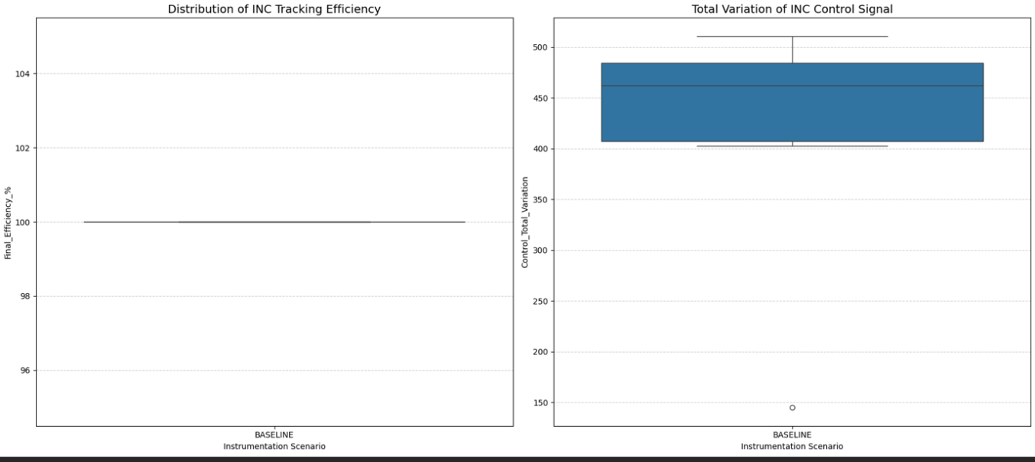
Figure 3. Global MPPT performance metrics under embedded execution.

3.2 Environmental Consistency across Irradiance and Temperature
Figure 4 visualizes the efficiency heatmap as a function of irradiance and temperature for the Incremental Conductance (INC)-based Maximum Power Point Tracking (MPPT) executed within our digital twin. The uniform distribution of efficiency across the entire explored operating domain shows that we successfully implemented environmental dependencies in the photovoltaic model, which are consistently propagated through the virtual instrumentation layer and accurately perceived by the embedded controller. Notably, no regions of degraded performance or anomalous behavior are observed, confirming the high fidelity of our environmental modeling within the digital twin.
This result validates the accuracy of the digital twin's environmental modeling and confirms that irradiance and temperature variations do not introduce artificial artifacts or bias in the embedded MPPT execution.
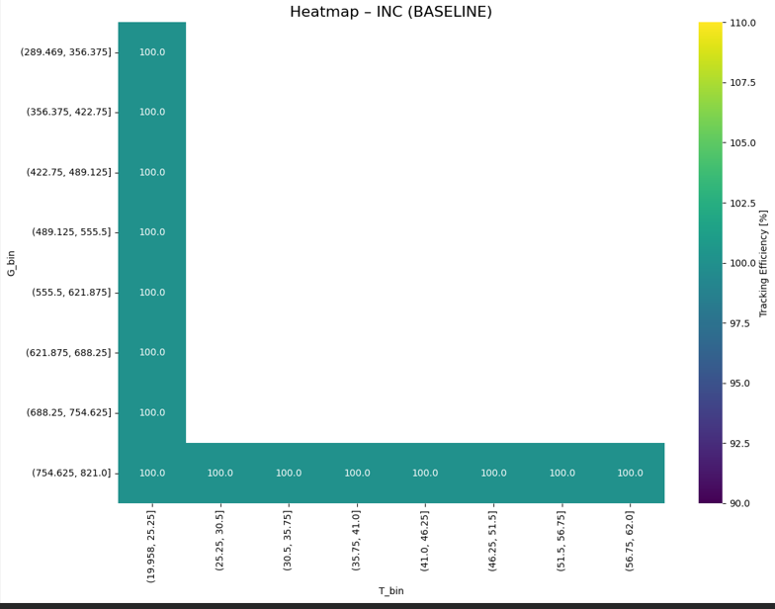
Figure 4. Tracking efficiency as a function of irradiance and temperature.

3.3 Time-Domain Control Behavior and Dynamic Response
Figures 5 to 6 display the time-domain evolution of crucial variables during experimental scenarios, including extracted power, tracking efficiency, MPPT control signal, and equivalent load resistance. As shown in top of the Figure 4, the extracted power closely tracks the imposed environmental profiles, featuring rapid and repeatable convergence to new operating points. The narrow ±1 standard deviation envelopes across multiple runs confirm this consistency.
Despite this swift convergence, top of the Figure 5 reveals that the MPPT control signal continuously adjusts around the operating point. These adjustments are reflected physically in bottom of the Figure 5, where the equivalent load resistance varies accordingly. This behavior demonstrates that the MPPT algorithm does not settle into a static operating point but instead maintains regulation through iterative updates. Notably, at the bottom of the Figure 5 shows that tracking efficiency remains at 100% throughout these dynamic adjustments. The combination of perfect efficiency and persistent control activity highlights a key strength of the proposed digital twin: it exposes control effort and dynamics that remain invisible in efficiency-only evaluations.
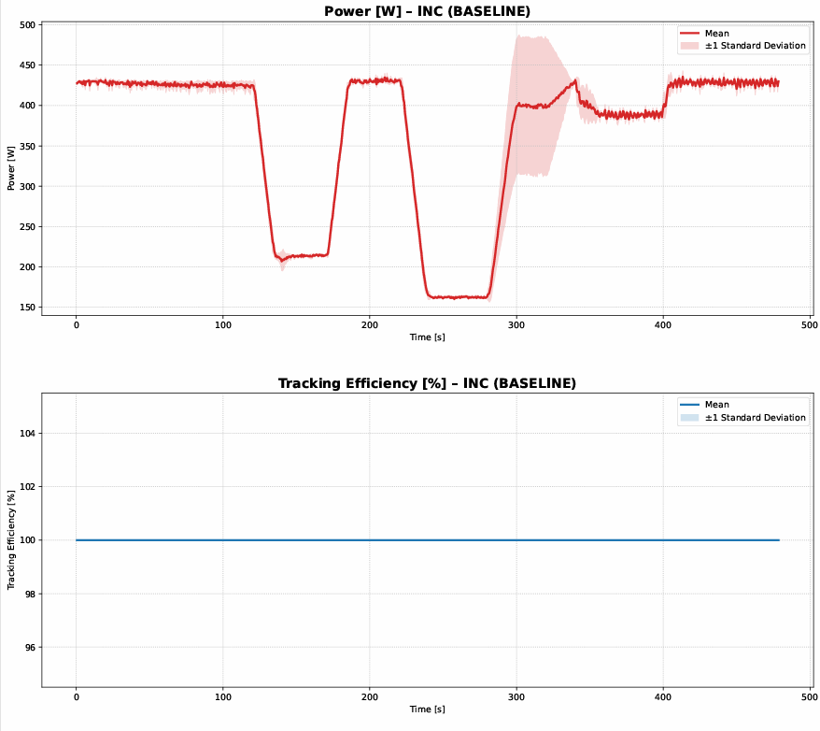
Figure 5(a). Time-domain evolution of extracted photovoltaic power; (b). Time-domain evolution of tracking efficiency
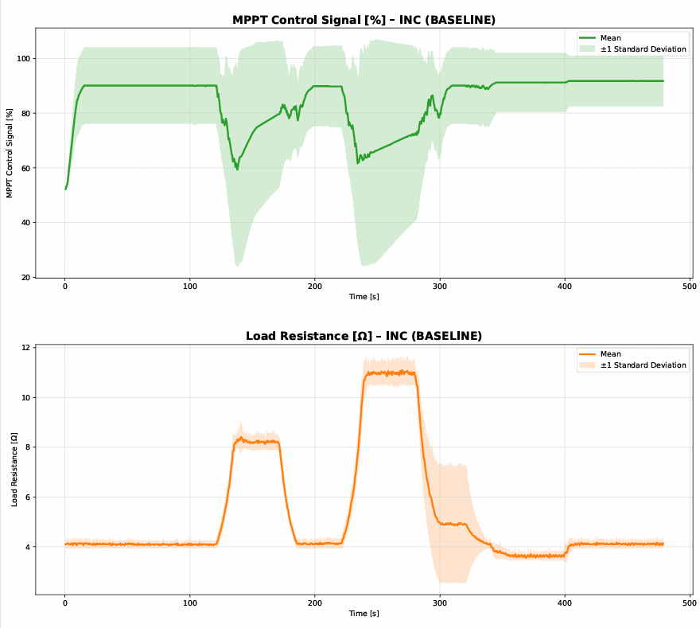
Figure 6. (a). Time-domain evolution of the MPPT control signal; (b). Time-domain evolution of the Equivalent load resistance trajectory

3.4 Spectral Characteristics and Stability
Figure 7 presents the frequency-domain analysis of the MPPT control signal, obtained through average Fast Fourier Transform (FFT) processing. A Hanning window and 50% overlap were used to compute the power spectral density, allowing the oscillatory content of the control variable to be characterized under consistent spectral estimation conditions. The spectral energy distribution reveals a concentration at low frequencies, indicating stable closed-loop operation without high-frequency oscillations or numerical instability. This confirms that the embedded execution of the INC algorithm within the digital twin accurately reproduces the expected stability characteristics of a practical MPPT-controlled photovoltaic system. Frequency-domain behavior is analyzed via FFT to characterize oscillatory content in the control variable [31].
The presence of low-frequency components is attributed to the intrinsic iterative nature of the Incremental Conductance algorithm, demonstrating that the digital twin is suitable for advanced spectral and stability analysis. These results further validate that the platform captures realistic embedded behavior rather than idealized numerical convergence.
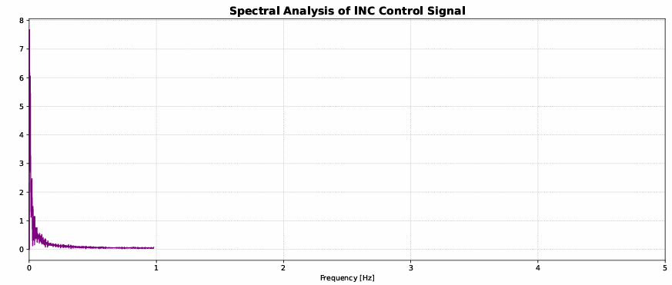
Figure 7. Spectral analysis of the MPPT control signal.

4. Discussion

Before presenting the graphical results, Table 4 summarizes the main embedded-control indicators obtained from the three evaluated test families. The comparison includes the MPPT tracking efficiency, ηMPPT, the mean dynamic index, MDI, the steady-state power oscillation, σP, and the convergence time, tconv. These indicators are not intended to benchmark the MPPT algorithm itself, but to provide a compact numerical characterization of the closed-loop behavior reproduced by the proposed measurement-aware digital twin under the tested operating conditions.
Table 4. Comparative embedded-control indicators obtained from the three evaluated test families.
Case | Test family | ηMPPT (%) | MDI (% load/sample) | σP (W) | tconv (s)
A | PO | 99.98 | 0.37 | 1.11 | ≤ 0.51
B | POINC | 99.98 | 0.43 | 1.10 | ≤ 0.51
C | POINCADAP | 99.98 | 0.42 | 1.12 | ≤ 0.51

The MPPT tracking efficiency, ηMPPT, was computed from the normalized ratio between the extracted photovoltaic power and the theoretical reference power reconstructed from the irradiance and temperature profiles. The mean dynamic index, MDI, was calculated as the average absolute variation of the control variable, expressed in percentage load points per sample. We obtained the steady-state power oscillation, σP, as the standard deviation of the photovoltaic power under nominal steady-state environmental conditions. Since all cases reached the reference operating region from the first recorded samples, the convergence time, tconv, is reported as being within one acquisition interval. The labels PO, POINC, and POINCADAP correspond to the three experimental test families used to evaluate the embedded behavior of the proposed digital twin. PO represents the reference operating profile, POINC corresponds to the Incremental Conductance embedded control profile, and POINCADAP corresponds to the adaptive Incremental Conductance embedded control profile.

The collective results presented in Figures 2–8 demonstrate that the proposed instrumented digital twin accurately and reproducibly simulates an embedded photovoltaic control system operating under MPPT regulation. While traditional metrics such as tracking efficiency verify correct energy extraction, the time-domain and spectral analyses reveal additional control dynamics that are relevant for understanding real embedded behavior. The ability to observe control effort, dynamic adjustment, and stability-related characteristics establishes the proposed digital twin as a useful validation and analysis tool.

Compared to previous digital twin and hardware-in-the-loop architectures for photovoltaic systems, including FPGA-based platforms, Modelica co-simulation environments, and RT-LAB implementations, the proposed approach presents clear advantages in accessibility, reproducibility, and ease of deployment. By employing Wokwi and a standard ESP32-based embedded controller, the platform reduces the technical and infrastructure barriers commonly associated with professional real-time simulation environments. This makes it particularly suitable for early-stage prototyping, algorithmic exploration, educational activities, and reproducible experimentation under controlled measurement constraints.

However, the proposed platform should not be interpreted as a replacement for professional HIL systems. Its main limitations are associated with real-time fidelity, scalability to higher-power photovoltaic systems, and the representation of high-frequency switching phenomena. Therefore, the digital twin is better understood as a complementary validation environment that supports early embedded development and measurement-aware analysis before moving toward more demanding real-time HIL or laboratory-scale implementations.

The discussion of the results obtained also highlights five main contributions of the proposed work. First, the study introduces a measurement-aware PV validation pipeline that verifies whether the simulated photovoltaic module preserves manufacturer-level environmental dependencies. This pipeline integrates embedded data acquisition, transient removal, smoothing, and datasheet-style normalization to generate consistent temperature- and irradiance-dependence curves, reducing modeling bias and preventing non-physical plotting artifacts.

Second, the work proposes an instrumented photovoltaic digital twin architecture that explicitly separates the physical PV plant model, the virtual instrumentation layer, and the embedded execution layer. This separation ensures that the embedded firmware interacts only with reconstructed measurements, replicating the information constraints present in real low-cost photovoltaic controllers.

Third, the proposed framework establishes an embedded-oriented experimental methodology for instrumentation sensitivity analysis. By varying sensing ranges, effective resolution, and measurement distortion, the platform makes it possible to stress-test embedded control behavior under realistic measurement limitations. This enables quantitative analysis of instrumentation-induced effects such as quantization-driven limit cycling, sensitivity amplification in finite-difference calculations, and noise-induced tracking disturbances.

Fourth, the proposed digital twin supports multi-domain diagnostic analysis beyond conventional static or energy-based indicators. The integration of time-domain, statistical, and frequency-domain characterization makes it possible to observe persistent dynamics, control effort, and stability-related behavior that remain hidden in idealized simulations. This broader diagnostic capability provides deeper insight into embedded photovoltaic control under measurement constraints.

Fifth, although Incremental Conductance is used as a representative embedded workload in this study, the platform is algorithm-agnostic and extensible. The proposed digital twin is not restricted to a specific MPPT algorithmic structure and can be adapted to other photovoltaic control strategies without structural changes. This enables repeatable experimentation under identical environmental excitation and measurement conditions.

Overall, these findings confirm that the platform functions correctly regardless of the specific MPPT algorithm used, fulfilling its intended role as a general, measurement-aware digital twin for photovoltaic system evaluation. The main value of the proposed approach lies in reproducible research, early-stage prototyping, and engineering education under realistic sensing and ADC constraints, while complementing, rather than replacing, professional HIL platforms when higher real-time fidelity, power-scale validation, or high-frequency switching analysis is required..

5. Conclusions
This paper presents an instrumented digital twin framework for photovoltaic systems that accurately reproduces the measurement and data acquisition constraints faced by embedded controllers. We integrated a physically consistent PV model with a virtual instrumentation layer and firmware-level execution on an ESP32, ensuring that our control code interacts only with reconstructed measurements rather than ideal internal model variables.
We validated our approach through a preliminary step, confirming the environmental consistency of the simulated PV behavior. After removing boundary transients and applying smoothing, we observed the expected datasheet- level trends: maximum power decreases monotonically with increasing temperature and scales linearly with irradiance, while open-circuit voltage exhibits limited dependence on irradiance. This verification supports the credibility of our digital twin as a controlled experimental plant for subsequent embedded experiments.
Instead of proposing new MPPT methods or conducting algorithm comparisons, we used Incremental Conductance as a representative embedded control workload to expose instrumentation-driven effects under realistic execution constraints. Our results demonstrate that even when conventional energy-based metrics indicate correct operation, time-domain and spectral analyses reveal persistent control activity and dynamics that are often hidden in idealized simulations, highlighting the importance of measurement-aware validation.
The key strength of our framework lies in the strict separation between the physical plant modeling and the embedded control logic. Because our firmware only perceives quantized and potentially noisy measurements produced by the virtual sensing chain, the observed behavior emerges from the same information limitations that exist in practical low-cost PV controllers. This design enables objective and repeatable experimentation while avoiding the risks, cost, and complexity of full power-electronics laboratory prototyping.
Overall, our proposed instrumented digital twin serves as a reliable intermediate layer between theoretical development and real deployment for embedded photovoltaic control applications. While it does not replace hardware testing, it significantly improves the development process by enabling systematic stress testing of sensing range selection, ADC resolution, and noise conditions, and it provides a reproducible platform for research and education in measurement-aware photovoltaic control..
Supplementary Materials: The supplementary Wokwi projects associated with this study are publicly available and can be used by readers as open reference implementations for reproducing, inspecting, and extending the proposed firmware-in-the-loop photovoltaic validation workflow. The photovoltaic panel testing environment is available at: https://wokwi.com/projects/466130372701506561. This project enables users to evaluate the photovoltaic panel model, modify operating conditions, and analyze the reconstructed voltage, current, irradiance, temperature, and power signals used by the embedded controller. The MPPT algorithm implementations used to verify and reproduce the experimental workflow are available at: https://wokwi.com/projects/451089645119177729; https://wokwi.com/projects/451090248996229121; and https://wokwi.com/projects/451089276729253889. These public projects allow researchers and practitioners to confirm the MPPT control logic, reproduce the firmware-in-the-loop experiments, and modify the embedded code, sensing configuration, or control parameters according to their own application requirements.
Author Contributions: For research articles with several authors, a short paragraph specifying their individual contributions must be provided. The following statements should be used “Conceptualization, C.R.S.S. and A.D.C; methodology, C.R.S.S.; software, C.R.S.S.; validation, C.R.S.S., and A.D.C.; formal analysis, C.R.S.S. and Y.E.G.R.; investigation, C.R.S.S.; resources C.R.S.S. and Y.E.G.R. and A.D.C.; data curation, C.R.S.S.; writing—original draft preparation, C.R.S.S.; writing—review and editing, Y.E.G.R. and A.D.C.; visualization, C.R.S.S.; supervision, Y.E.G.R.; project administration, C.R.S.S.; funding acquisition, C.R.S.S. and Y.E.G.R. and A.D.C.. All authors have read and agreed to the published version of the manuscript.” Please turn to the CRediT taxonomy for the term explanation. Authorship must be limited to those who have contributed to the work reported.
Funding: This research was funded by the Faculty of Engineering and Basic Sciences of Fundación Universitaria Los Libertadores, through the Direction de Investigation. The APC was funded by Fundación Universitaria Los Libertadores.
Data Availability Statement: The data supporting the results reported in this study were generated through the proposed Wokwi-based firmware-in-the-loop photovoltaic digital twin. The embedded firmware, virtual sensing configuration, MPPT implementation, and experimental test scenarios are publicly available through the following Wokwi projects: [insert Wokwi link 1], [insert Wokwi link 2], and [insert Wokwi link 3]. These projects allow researchers to reproduce the ESP32-based execution environment, modify photovoltaic module parameters, adjust instrumentation constraints, and repeat the MPPT tests under the same measurement-aware validation structure. The processed datasets and analysis scripts used to generate the figures and performance indicators are available at: [insert GitHub/Zenodo/OSF link, if available]..
Acknowledgments: The authors acknowledge Fundación Universitaria Los Libertadores, particularly the Faculty of Engineering and Basic Sciences and the Direction of Investigation, for the institutional support provided during the development of this research. The authors also appreciate the support granted in terms of research time, administrative guidance, and financial backing for the preparation and publication process of this paper. During the preparation of this manuscript/study, the author(s) used Gemini pro for the purposes of graphics, data analysis and interpretation of data. The authors have reviewed and edited the output and take full responsibility for the content of this publication.
Conflicts of Interest: Declare conflicts of interest or state “The authors declare no conflicts of interest.” Authors must identify and declare any personal circumstances or interest that may be perceived as inappropriately influencing the representation or interpretation of reported research results. Any role of the funders in the design of the study; in the collection, analyses or interpretation of data; in the writing of the manuscript; or in the decision to publish the results must be declared in this section. If there is no role, please state “The funders had no role in the design of the study; in the collection, analyses, or interpretation of data; in the writing of the manuscript; or in the decision to publish the results.”

Abbreviations
The following abbreviations are used in this manuscript:
MPPT | Maximum Power Point Tracking
ADC | Analog to Digital Converter
PV | Photovoltaic
MIL | Model in The Loop
SIL | Software in The Loop
HIDL | Hardware in The Loop
C.R.S.S. | Carlos René Suárez S.
Y.E.G.R. | Yimy Edison Garcia Rivera
A.D.C. | Alfonso Duran Caicedo

References
1. Sivakumar, P.; Abdul Kader, A.; Kaliavaradhan, Y.; Arutchelvi, M. Analysis and Enhancement of PV Efficiency with Incremental Conductance MPPT Technique under Non-Linear Loading Conditions. Renew. Energy 2015, 81, 543–550, doi:10.1016/j.renene.2015.03.062.
2. Zhani, N.; Mahmoudi, H. Comparison of the Performance of MPPT Control Techniques (Fuzzy Logic, Incremental Conductance and Perturb & Observe) under MATLAB/Simulink. In Proceedings of the IFAC-PapersOnLine; Elsevier B.V., July 1 2024; Vol. 58, pp. 617–623.
3. Esram, T.; Chapman, P.L. Comparison of Photovoltaic Array Maximum Power Point Tracking Techniques. IEEE Transactions on Energy Conversion 2007, 22, 439–449, doi:10.1109/TEC.2006.874230.
4. Dhimish, M. Assessing MPPT Techniques on Hot-Spotted and Partially Shaded Photovoltaic Modules: Comprehensive Review Based on Experimental Data. IEEE Trans. Electron Devices 2019, 66, 1132–1144, doi:10.1109/TED.2019.2894009.
5. De Soto, W. Improvement and Validation of a Model for Photovoltaic Array Performance; 2004;
6. Ishaque, K.; Salam, Z.; Taheri, H.; Syafaruddin Modeling and Simulation of Photovoltaic (PV) System during Partial Shading Based on a Two-Diode Model. Simul. Model. Pract. Theory 2011, 19, 1613–1626, doi:10.1016/j.simpat.2011.04.005.
7. Pal, I.J.; Ramana, V.V. Integrated Perturbation and Global Peak Tracking MPPT Approach with Pattern Detection for PV Module. Renew. Energy 2026, 259, doi:10.1016/j.renene.2025.125047.
8. Nusrat, M.; Mekhilef, S.; Mubin, M.; Ahmed, S.; Seyedmahmoudian, M.; Stojcevski, A.; Alshammari, O. Advancements in Flexible Power Point Tracking and Power Control Strategies for Photovoltaic Power Plants: A Comprehensive Review. Energy Reports 2024, 12, 237–250, doi:10.1016/j.egyr.2024.06.012.
9. Grieves, M.; Vickers, J. Digital Twin: Mitigating Unpredictable, Undesirable Emergent Behavior in Complex Systems. In Transdisciplinary Perspectives on Complex Systems; Springer International Publishing: Cham, 2017; pp. 85–113.
10. Uhlemann, T.H.J.; Lehmann, C.; Steinhilper, R. The Digital Twin: Realizing the Cyber-Physical Production System for Industry 4.0. In Proceedings of the Procedia CIRP; Elsevier B.V., 2017; Vol. 61, pp. 335–340.
11. De Carne, G.; Lauss, G.; Syed, M.H.; Monti, A.; Benigni, A.; Karrari, S.; Kotsampopoulos, P.; Faruque, M.O. On Modeling Depths of Power Electronic Circuits for Real-Time Simulation - A Comparative Analysis for Power Systems. IEEE Open Access Journal of Power and Energy 2022, 9, 76–87, doi:10.1109/OAJPE.2022.3148777.
12. Faruque, M.O.; Strasser, T.; Lauss, G.; Jalili-Marandi, V.; Forsyth, P.; Dufour, C.; Dinavahi, V.; Monti, A.; Kotsampopoulos, P.; Martinez, J.A.; et al. Real-Time Simulation Technologies for Power Systems Design, Testing, and Analysis. IEEE Power and Energy Technology Systems Journal 2015, 2, 63–73, doi:10.1109/JPETS.2015.2427370.
13. Omar Faruque, M.O.; Dinavahi, V. Hardware-in-the-Loop Simulation of Power Electronic Systems Using Adaptive Discretization. IEEE Transactions on Industrial Electronics 2010, 57, 1146–1158, doi:10.1109/TIE.2009.2036647.
14. Al-Shammaa, A.A.; Abdurraqeeb, A.M.; Noman, A.M.; Alkuhayli, A.; Farh, H.M.H. Hardware-In-the-Loop Validation of Direct MPPT Based Cuckoo Search Optimization for Partially Shaded Photovoltaic System. Electronics (Switzerland) 2022, 11, doi:10.3390/electronics11101655.
15. Schluse, M.; Priggemeyer, M.; Atorf, L.; Rossmann, J. Experimentable Digital Twins-Streamlining Simulation-Based Systems Engineering for Industry 4.0. IEEE Trans. Industr. Inform. 2018, 14, 1722–1731, doi:10.1109/TII.2018.2804917.
16. Pavan, S.; Pavan, S., S.R.; Pavan, S., S.R., & T.G.C. Understanding Delta-Sigma Data Converters; John Wiley & Sons, 2017;
17. San, Y.; St, F.; Louis Bangkok, B.; Caracas, K.; Lumpur, L.; London, M.; Mexico, C.; Milan, M.; New, D.; Santiago, S.; et al. Schaum’s Outline Series in Electronics & Electrical Engineering DESIGN WITH OPERATIONAL AMPLIFIERS AND ANALOG INTEGRATED CIRCUITS;
18. Kester, W. MT-006 TUTORIAL ADC Noise Figure-An Often Misunderstood and Misinterpreted Specification; Vol. 14;.
19. Peterchev, A. V.; Sanders, S.R. Quantization Resolution and Limit Cycling in Digitally Controlled PWM Converters. IEEE Trans. Power Electron. 2003, 18, 301–308, doi:10.1109/TPEL.2002.807092.
20. González-Castaño, C.; Restrepo, C.; Giral, R.; Vidal-Idiarte, E.; Calvente, J. Adc Quantization Effects in Two-Loop Digital Current Controlled Dc-Dc Power Converters: Analysis and Design Guidelines. Applied Sciences (Switzerland) 2020, 10, 1–15, doi:10.3390/app10207179.
21. Buso, S., & M.P. Digital Control in Power Electronics.; Springer Nature, Ed.; 2022;
22. Dai, X.; Zou, Y.; Sun, Y. Uncertainty Modeling and Robust Control for LCL Resonant Inductive Power Transfer System. Journal of Power Electronics 2013, 13, 814–828, doi:10.6113/JPE.2013.13.5.814.
23. Hussein, K.H., M.I., H.T., & O.M. Maximum Photovoltaic Power Tracking : An Algorithm for Rapidly Changing Atmospheric Conditions; 1995;
24. Femia, N.; Petrone, G.; Spagnuolo, G.; Vitelli, M. Optimization of Perturb and Observe Maximum Power Point Tracking Method. IEEE Trans. Power Electron. 2005, 20, 963–973, doi:10.1109/TPEL.2005.850975.
25. Lyden, S.; Haque, M.E. Maximum Power Point Tracking Techniques for Photovoltaic Systems: A Comprehensive Review and Comparative Analysis. Renewable and Sustainable Energy Reviews 2015, 52, 1504–1518, doi:10.1016/j.rser.2015.07.172.
26. Safari, A.; Mekhilef, S. Simulation and Hardware Implementation of Incremental Conductance MPPT with Direct Control Method Using Cuk Converter. IEEE Transactions on Industrial Electronics 2011, 58, 1154–1161, doi:10.1109/TIE.2010.2048834.
27. Worku, M.Y.; Hassan, M.A.; Maraaba, L.S.; Shafiullah, M.; Elkadeem, M.R.; Hossain, M.I.; Abido, M.A. A Comprehensive Review of Recent Maximum Power Point Tracking Techniques for Photovoltaic Systems under Partial Shading. Sustainability (Switzerland) 2023, 15.
28. Chellal, M.; Fialho Guimarães, T.; Leite, V. Experimental Evaluation of MPPT Algorithms: A Comparative Study; 2021; Vol. 11;.
29. Ahmed, J.; Salam, Z. A Critical Evaluation on Maximum Power Point Tracking Methods for Partial Shading in PV Systems. Renewable and Sustainable Energy Reviews 2015, 47, 933–953.
30. Pathy, S.; Subramani, C.; Sridhar, R.; Thamizh Thentral, T.M.; Padmanaban, S. Nature-Inspired MPPT Algorithms for Partially Shaded PV Systems: A Comparative Study. Energies (Basel). 2019, 12, doi:10.3390/en12081451.
31. John G. Proakis, D.G.M. Digital Signal Processin; Pearson Prentice Hall, Ed.; 4th ed.; New York, 2007; ISBN 9780131873742,0131873741.

Disclaimer/Publisher’s Note: The statements, opinions and data contained in all publications are solely those of the individual author(s) and contributor(s) and not of MDPI and/or the editor(s). MDPI and/or the editor(s) disclaim responsibility for any injury to people or property resulting from any ideas, methods, instructions or products referred to in the content.

